**Setting up a schema for the corpus data**

1. Install the MySQL workbench from the link <https://www.mysql.com/products/workbench/>
2. After installation, open the workbench and click the create schema button on the top menu.

C:\Users\136114\Downloads\screenshot\createdb.jpg

1. After that, you will be prompted to enter schema name. You may enter any name but here “CorpusDB” was entered as the schema name.

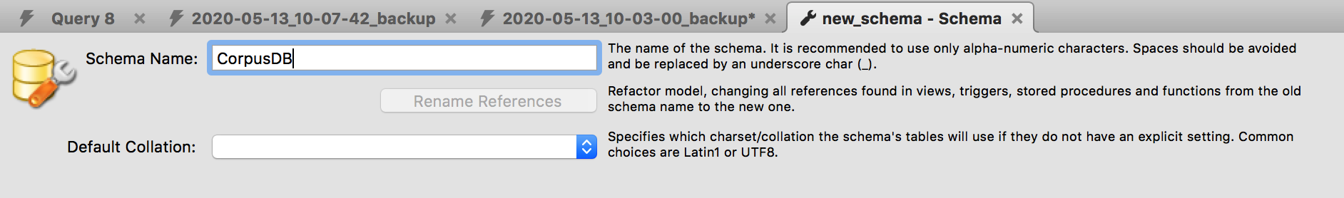

1. Continue to click next/ok and leave everything empty or default. Once the schema is created, you may see it appear on the lower left corner section called “SCHEMAS”.

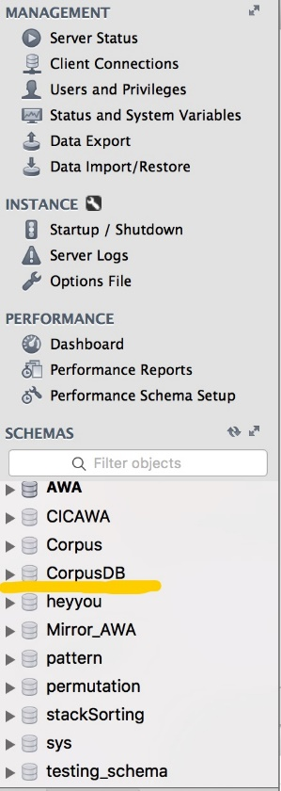

1. Double click on the newly created schema. Next, click “Open a SQL script file..” button from the top menu and you will be prompted to select a SQL script.

C:\Users\136114\Downloads\screenshot\loadSQL.jpg

1. Select the **SQL dump script** provided and a dialogue box will be prompted asking to “Open” or “Run SQL Script”. **Choose “Run SQL Script” to run the SQL dump script directly without opening it.**

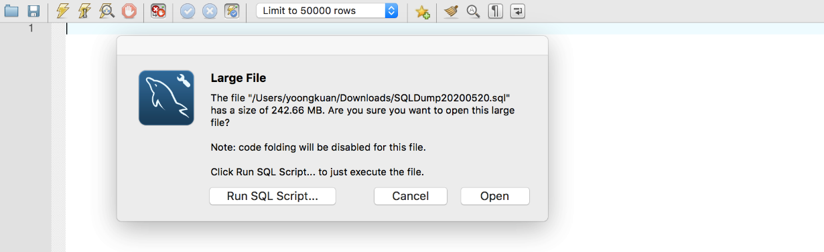

1. Then, click “Run” on the next page and the data import process will be run automatically.

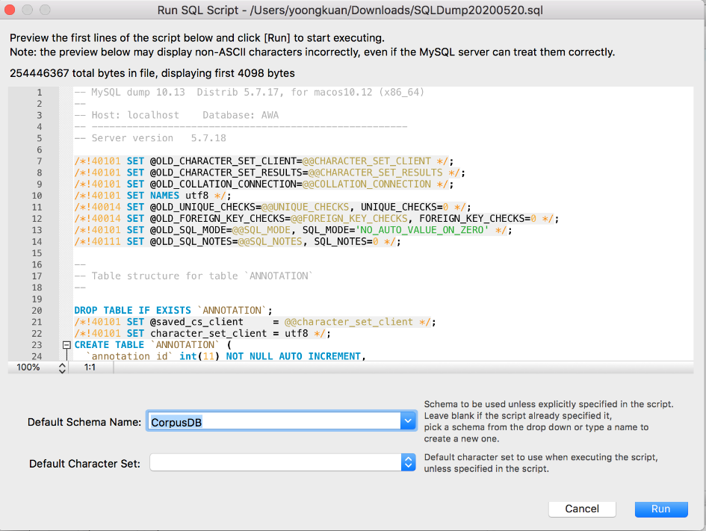

1. Finally, a completion message would be displayed after the import process is completed successfully.

